**Migration Process**

* Connect to server 10.51.100.51 with your Itronms account
* Open Veeam Backup and Replication and log in with windows credentials (Domain Admin group is the only one allowed)
* At the top select replication Job and then the VMware vSphere button as shown below.

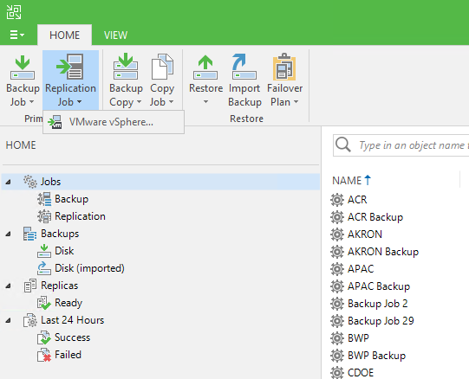

* Name your job with something relevant in the name field, and leave the description with your name and date/time and check the boxes as below then click next.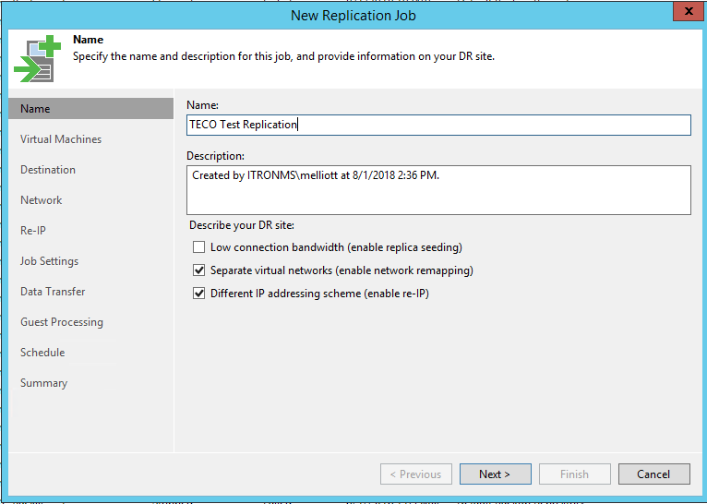
* Click Add Button on the right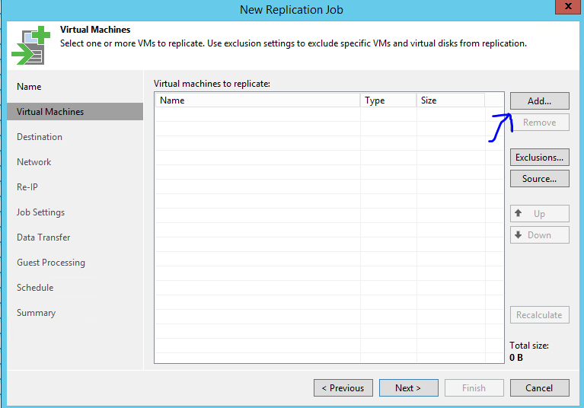
* 172.24.100.51 is the Liberty Lake V-Center Inventory where as esxtpll-vc01 is the TierPoint Inventory. From here select the servers you would like to Migrate. Select the servers and click Add. Note you can do them all at once or create separate jobs for each on depending on preference.

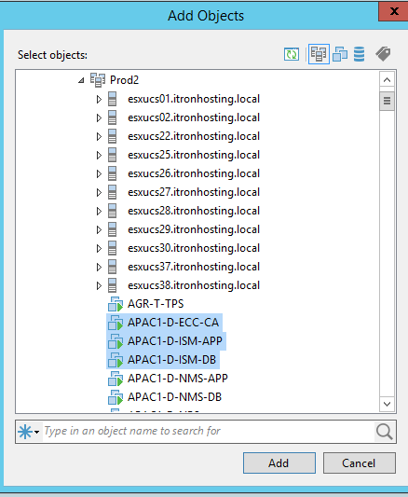

* Total size will be shown on the bottom right, plan appropriately then click next.

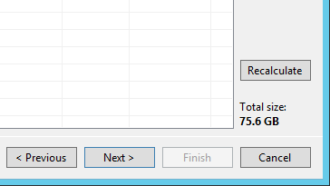

* You must select a host at the host and cluster box, do not just do a cluster select a specific host. Once the host is picked select the resource, the VM folder you want them to appear in and the data store that has enough room to support the VM’s

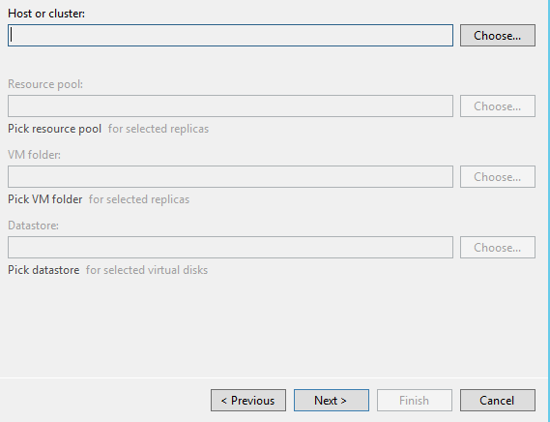

* In the networking tab push Add then select the Source Network (The ones in Liberty Lake) and the Target Network (The new one in Tierpoint). If you have not created the port group, you need to do it now.

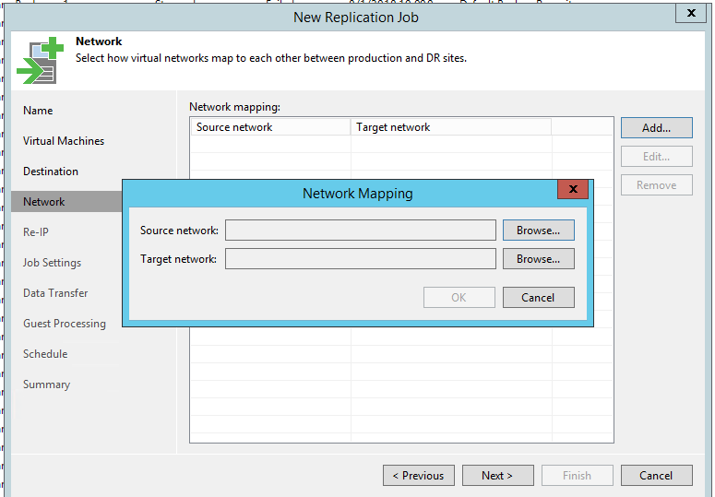

* On the Re-IP Tab click add then put in the Source IP (Old one from Liberty Lake) with the Target VM (New one going into TierPoint).

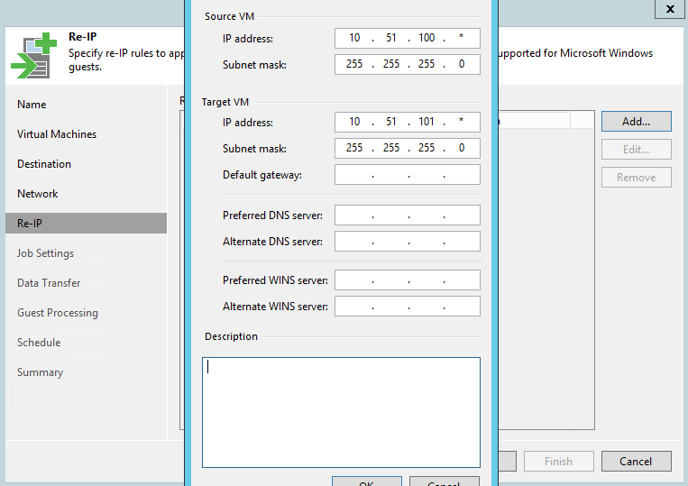

* Under Job Settings you can usually default the repository (unless doing testing) Replica Suffix name is going to be what appears in Vcenter in this case below if our server was Test-T-FND-APP it would be TEST-T-FND-APP_replica. The default of 7 restore points is fine and most advanced settings should not need to be touched.

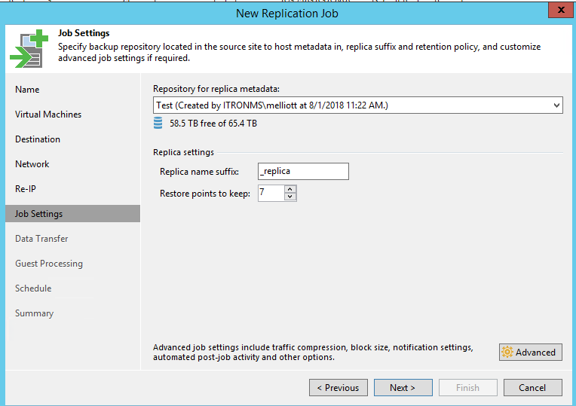

* For Guest Processing we can leave it as not enabled.

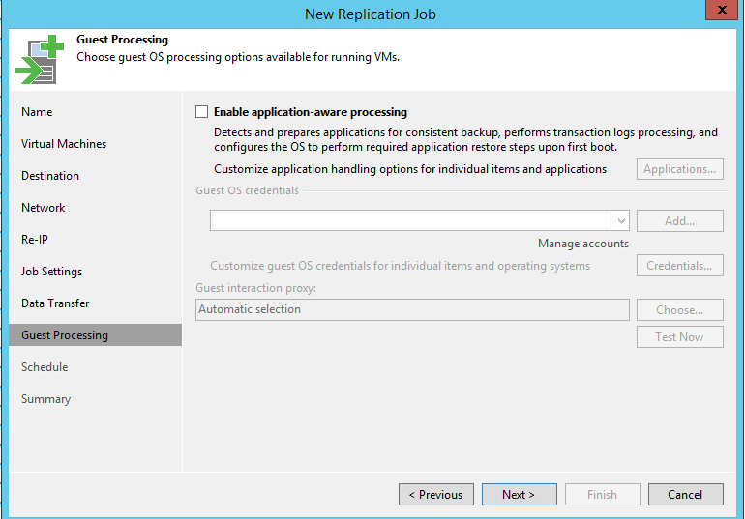

* Skip over schedule and when you hit summary select the box that says Run the job when I click Finish. Once you click Finish the job will run and you can monitor it.

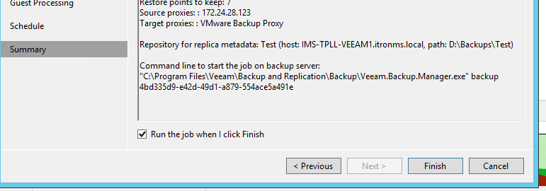

* Once the VM’s are moved you will need to update VMware tools, and do some checks to make sure the data has all moved over properly and everything is working. Check the IP’s and the NIC’s to make sure the transfer was successful. Make sure you can log into the boxes and the domain is still authenticating, ect.